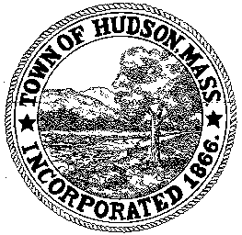

CONSERVATION COMMISSION
78 Main Street, Hudson, MA 01749
(978) 562-2020

Paul Byrne, Chairman W. Minot Wood, Vice Chairman David Esteves, Member

Terrence Joyce, Member Leif Longtine, Member Joseph Rodrigues, Member Al Tashian, Member

Meeting Agenda
October 6, 2011 7:00 P.M.

- Preliminaries
  - Open Meeting
  - Roll Call

2.0 New Business
2.1 RDA 414
Applicant: Hudson Youth Baseball
Location: Boutwell Field
Project Description: Installation of lighting on Field 2 and Field 3

2.2 Enforcement Order
144 Brook Street

2.3 DEP 190-0507
Request for Certificate of Compliance
Applicant: Jose and Maria Chaves
Location: 4 Third Street

2.2 Minutes – September 15, 2011

3.0 Old Business
3.1 Proposal from SEA and Oxbow for evaluation of Hog’s Brook and Tripp’s Pond – table, have not received

4.0 Correspondence
4.1 E-mail from Janice Long regarding landscaping at the Senior Center
4.2 Request for update to database

5.0 Executive Session
5.1 To discuss pending litigation of which public discussion could impair the Town and Boards position in litigation.

Next Meeting: October 20, 2011

